Isolated Words Recognition in Speech Signal Processing

Submitted in partial fulfillment of the requirements for the degree of

Bachelor of Technology
in
Electronics and Communication Engineering

by
RAHUL KHANNA
13BEC0700

Under the guidance of
Prof. S. Kalaivani
School of Electronics Engineering,
VIT University, Vellore.



May, 2017
DECLARATION

I hereby declare that the thesis entitled “Isolated words recognition in speech signal processing” submitted by me, for the award of the degree of Bachelor of Technology in Electronics and Communication Engineering to VIT University is a record of bonafide work carried out by me under the supervision of S. Kalaivani.
I further declare that the work reported in this thesis has not been submitted and will not be submitted, either in part or in full, for the award of any other degree or diploma in this institute or any other institute or university.

Place : Vellore
Date :
Signature of the Candidate

CERTIFICATE

This is to certify that the thesis entitled “S. Kalaivani” submitted by Rahul Khanna, School of Electronics Engineering, VIT University, for the award of the degree of Bachelor of Technology in Communication Engineering, is a record of bonafide work carried out by him under my supervision, as per the VIT code of academic and research ethics.

The contents of this report have not been submitted and will not be submitted either in part or in full, for the award of any other degree or diploma in this institute or any other institute or university. The thesis fulfills the requirements and regulations of the University and in my opinion meets the necessary standards for submission.

Place : Vellore
Date : Signature of the Guide

The thesis is satisfactory / unsatisfactory

Internal Examiner External Examiner

Approved by

Program Chair [B.Tech ECE]
School of Electronics Engineering
ACKNOWLEDGEMENTS

I am thankful to our honorable Chancellor Dr. G Vishwanathan for providing us with a world class institution filled with research facilities. I would also like to thank our Dean Dr. Elizabeth Rufus I would also like to thank Dr. Renuga Devi, HOD School of Electronics Engineering, for giving us such internship opportunities, which gives us an insight into the industrial word
I take the opportunity to express my profound gratitude and deep regards to my guide Professor S. Kalaivani for this exemplary guidance, monitoring and constant encouragement throughout the course of this project. The blessing, help and guidance given by her time to time shall carry me a long away in the journey of life o which I am about to embark.
I also express my sincerest regards to my friends and family who encouraged me throughout the course of this work.

Rahul Khanna

Executive Summary

Speech is the most common and basic means among humans to communicate and to transfer and exchange information to other human beings. But, what if a person wants to communicate with a machine? How can machine understand what a person is speaking?
An Automated Speech Recognition (ASR) System answers and solves the above mentioned queries. An ASR is system that is trained and tested for recognizing the words and speeches spoken by the speaker. It can also be used for identifying the speaker and also, for speaker verification. The given report deals with the isolated word recognition part of ASR system.
English numbers, 0-9, are considered for the isolated word recognition purpose. The isolated word recognition system is designed in this report uses HHT, MFCC, LBG and Masking concepts. The traditional way of finding spectrum (FFT) is replaced by HHT, due to physically more realistic and meaningful nature of HHT. Also, the usual way of concentrating useful in lower frequencies (pre-emphasizing) is replaced by Adaptive Time-Frequency Masking.
The system takes the input speech signal at 16 kHz of sampling rate. Then the signal is divided into n number of hamming windowed frames of 25ms with 25% of overlapping. Then, the adaptive time frequency mask is applied to every frame. The masked output is smoothened using mean smoothing filtering technique. The final masked output is used get the spectrum, by using HHT. Then, spectrum is passed through Mel filter-bank to extract 12 MFCC features. Delta and delta delta features and their logarithmic energies are also extracted to calculate the dynamic features of the frame. The extracted features are then quantized (using LBG algorithm) to form the codebook, that would be used for training and testing purpose.
All the calculations and steps are written, complied and executed in MATLAB.

CONTENTS |  |  |  |  | Page No.
 | Acknowledgement |  |  |  | i
 | Executive Summary |  |  |  | ii
 | Table of Contents |  |  |  | iii
 | List of Figures |  |  |  | v
 | List of Tables |  |  |  | vi
 | Abbreviations |  |  |  | vii
 | Symbols and Notations |  |  |  | viii
1 | INTRODUCTION |  |  |  | 1
 | 1.1 | Objective |  | 1
 | 1.2 | Motivation |  | 2
 | 1.3 | Background |  | 3
2 | PROJECT DESCRIPTION AND GOALS  2.1 Project Description  2.2 Goals |  |  | 4  4  4
3 | TECHNICAL SPECIFICATION  3.1 Isolated Word Recognition System ( General Method)  3.2 Adaptive Time Frequency Masking  3.2.1 SNR Estimation  3.2.2 Time Frequency Masking  3.2.3 Mean Smoothing Filtering  3.3 Hilbert Huang Transform  3.3.1 Empirical Mode Decomposition process  3.3.2 Amplitude and Frequency Extraction  3.4 Mel Frequency Cepstral Coefficients  3.5 Linde Buzo Gray Algorithm |  |  |  | 5  5  6  6  7  7  7  7  8  8  10
4 | DESIGN APPROACH AND DETAILS |  |  |  | 11
 | 4.1 Design Approach  4.2 Codes and Standards  4.3 Constraints, Alternatives and Tradeoffs |  |  |  | 11  13  13
5 | SCHEDULE, TASKS AND MILESTONES |  |  |  | 14
6 | PROJECT DEMONSTRATION  6.1 System Workflow  6.2 Results |  |  |  | 15  15  18
7 | COST ANALYSIS |  |  |  | 20
8 | SUMMARY |  |  |  | 21
9 | REFERENCES |  |  |  | 22
 | APPENDIX A  Publication Details  Curriculum vitae |  | a-b  a  b

List of Figures

Figure No. | Title | Page No.
3.1 | Block diagram of general isolated word recognition system | 5
3.2  4.1  4.2  6.1  6.2  6.3  6.4  6.5  6.6  6.7 | Triangular filters used in the computation of the mel-cepstrum using Eq. [6]  Block diagram of proposed isolated word recognition system  Observational Approach  Input signal, English number 1  Frame 72 of input signal, English number 1  Time frequency masked output of frame 72 of input signal, English number 1  Mean smoothed masked output of frame 72 of input signal, English number 1  Frequency domain representation of frame 72 of input signal, English number  MFCC of frame 72 of input signal, English number 1  Spectrum of input signal, obtained by general system (left) and Spectrum of input signal, obtained by proposed system (right) | 9  11  12  15  15  16  16  17  17  18

List of Tables
Table No. | Title | Page No.
5.1  6.1  6.2 | Rough schedule followed and tasks completed.  Improvement in ESNR  Improvement by systems with HHT+masking and FFT+masking | 14  19  19

List of Abbreviations

ASR | Automatic Speech Recognition
FFT | Fast Fourier Transform
SNR | Signal to Noise Ratio
DCT | Discrete Cosine transform
EMD  DFT  PLP  RASTA-PLP  LPCC  MFCC  ANN  DTW  HMM  GMM  SVMs  STE  IMFs  AWGN | Empirical Mode Decomposition  Discrete Fourier Transform  Perceptual Linear Prediction  Relative Spectra Filtering of Log Domain Coefficients PLP  Linear Predictive Cepstral Coefficients  Mel Frequency Cepstral Coefficients  Artificial Neural Network  Dynamic Time Warping  Hidden Markov Model  Gaussian Mixture Model  Support Vector Machines  Short Time Energy  Intrinsic Mode Functions  Additive White Gaussian Noise

Symbols and Notations

 | Sampling frequency rate
 | Amplitude of signal at frequency k (Eq. [1.1])
 | Total number of frequencies to be considered (Eq. [1.1])
 | nth sample in speech signal (Eq. [2.1])
 | Index number of frame (Eq. [2.2])
 | Short time Energy of i^{th} frame (Eq. [2.2])
 | Constants (Eq. [2.3])
 | Frame index (Section 3.3.1)
 | Local maxima in frame t (Section 3.3.1)
 | Local minima in frame t (Section 3.3.1)
 | Number of zero crossings (Section 3.3.1)
 | Number of local peaks (Section 3.3.1)
 | IMFs (Section 3.3.1)
 | Signal formed by summation of all IMFs (Section 3.3.1)
 | Hilbert transform (Section 3.3.2)
 | Analytical signal (Section 3.3.2)
 | Mel scale value (Eq. [2.4])
 | Desired number of coefficients from each filter in filter bank (Section 3.4)
 | Range of Warped triangular filter bank (Section 3.4)
 | Number of centroids (Section 3.5)
, D’ | Deviation of every data vector from its centroid (Sec. 3.5)
 | Small variable value (Section 3.5)

- INTRODUCTION

  - OBJECTIVE
In today’s society people prefer options in technology that simplify activities. Using speech recognition, users could type text or issue device commands through speech. Systems like language translation and dictation could become simple hands-free devices. But for creating such ASR, the complexity and processing speed should be maintained. Hence, for creating an efficient ASR system some assumptions and predefined values are taken would decrease the processing time and make the system less complex.
In many ASR systems the input signal is pre emphasized to boost the spectrum in higher frequencies and FFT are used to compute the spectrum of the signal. Pre emphasizing is done to counter the roll off of the natural speech. But with boosting the spectrum, pre emphasizing also boosts the noise present at those frequency levels and thus increases the unwanted noise present. Like pre emphasizing, FFT also have its drawbacks. FFT cannot be used for non-stationary and non-linear signals. But speech signal is both. Due to this we get incomplete spectrum of the signal.
If the above methods are used for creating ASR system, than this would result in decrease in the efficiency and physically less realistic ASR model.
To mitigate the above mentioned problems, given thesis are presented with an objective to reduce noise without using pre emphasizing step and to compute spectrum of the speech signal, without using FFT. The mentioned objectives are achieved by using adaptive time frequency masking technique and Hilbert Huang Transform, respectively.
Adaptive time frequency masking uses the concept of estimated SNR for adaptively creating the mask of every frame and using it on that frame to reduce the noise in that frame. And, Hilbert Huang Method uses the concepts of intrinsic mode functions and signal monotonicity for computing the empirical mode decomposition of the speech signal. The EMD thus obtained is used for obtaining the analytical signal, who’s DCT will in turn provide the spectrum of the speech signal.

  - MOTIVATION
The complexity of every proposed ASR system varies. This variation is majorly introduced by the variation in the approach toward the feature extraction and decision making processes. Environmental noise, size of data set, circuitry used and assumptions made for the model; these are some other factors which also makes ASR systems to vary in their complexity. Thus, to make the system physically stable and more reliable, the complexity of the system increases.
But with this increase in complexity, the chances of getting an error and error resolving also increases. This makes the researchers to make the correct assumptions so that the chances of getting an error in further steps get reduced. To mitigate the error in speech recognition, pre- emphasizing is done. Pre emphasizing is used to boost the spectrum values in high frequencies to counter the roll-off of natural speech. This pre emphasizing is done by passing the input speech signal through first order high pass filter.
For spectral estimation, DFT is implemented on speech signal. DFT converts the time domain data into frequency domain. DFT to be computed is implemented by FFT using eq1. By using FFT, the number of computation decreases to from . Let X₀, X_{1,} X_{2, ....,} X_{N} be a complex numbers.
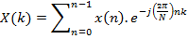 (k=0 ,1 ,2…N-1) Eq. ---[1.1].
But the methods discussed above can lead to increase in errors I the ASR system. The pre emphasizing used, not only boost the spectrum in higher frequencies, but also, it boosts the noise present at those frequency levels. This causes the increase in the unwanted noise in the system, which results in the wrong decision making result and hence decreases the efficiency of the system. Also, FFT used for estimating the spectrum of the speech signal does not compute the complete spectrum of the signal. FFT is implemented with two assumptions, i.e. the signal is stationary and linear and thus relies on globally defined orthogonal basis states. But speech signal is non-stationary and non-linear, thus using FFT does not compute the complete spectrum of the signal.
New methods for computing the spectrum and reducing the noise levels should be implemented to achieve more physically realistic ASR systems.

  - BACKGROUND
Speech is a natural phenomenon that occurs every single day. From a very early point in our lives we learn the necessary skills to use speech as a primary mode of communication. Because speech comes so naturally to us, it is easy to forget how complex it really is. It begins with lungs producing airflow and air pressure. This pressure then vibrates the vocal chords which separate the air flow into audible pulses. The muscles of the larynx then adjust the length and tension of the vocal cords to change the pitch and tone of the sound produced. The vocal tract, consisting of the tongue, palate, cheek and lips then articulate and filter the sound [1]. Each instance of speech that occurs after this process is very unique. Voices can vary in volume, speed, pitch, roughness, tone and other different aspects.

In today’s society people prefer options in technology that simplify activities. Using speech recognition, users could type text or issue device commands through speech. Systems like language translation and dictation could become simple hands-free devices. But with these ideas comes the complicated task of implementing the system. Speech recognition in computers is nowhere near the speech recognition capabilities of the human brain. But perhaps using systems that mimic human brain functions could lead to further advancements in the field.

The major steps in the ASR systems are feature extraction and decision making. Almost 80% of the functionality of ASR systems depends on these steps only. In feature extraction step, system uses the acoustic model of speech production to extracts the meaningful data of the recorded speech. Feature extraction techniques varies depending on the acoustic model technique used in the system. For feature extraction many of the techniques available in the literature. Some of commonly used feature extraction techniques are Perceptual Linear Prediction (PLP)[1], Relative Spectra Filtering of Log Domain Coefficients PLP (RASTA-PLP) [2] , Linear Predictive Coding [1], Linear Predictive Cepstral Coefficients (LPCC) [1], Mel-Frequency Cepstral Coefficients (MFCC) [1,3] and some other auditory features; such as first order derivative, energy normalization, formant [1,3].

In decision making step, system recognizes the recorded speech by implementing the concepts of probability and statistics on the data collected from its training. Different pattern recognizing techniques can used in decision making step, depending on the complexity and processing speed of the speed. In short, this step uses the concepts of probability and statistics to formulate the algorithm for correct pattern recognition. Some widely use algorithms are Hidden Markov Model (HMM) [3,4], Gaussian Mixture Model (GMM) [1], Dynamic Time Warping (DTW) [2], Decision Tress [5]. Nowadays, Artificial Neural Networks techniques [5] are more preferred and reliable than above techniques. Some ANN techniques are Multi-Layer Perceptron (MLP) [4], Recurrent Neural Network [5], Convolutional Neural Network [5] and Support Vector Machines (SVMs) [5].
- PROJECT DESCRIPTION AND GOALS

  - PROJECT DESCIPTION
The project is implemented and compared with the state of the art systems like adaptive time frequency masking and with FFT. The ASR system is trained on the speech data recorded by the three speakers, each of them three times pronounces the 0-9 English numbers. The numbers are recorded at 16 kHz. In isolated word recognition system each number signal is framed by 25ms overlapped hamming window with the overlapping of 25%. The ESNR is calculated for entire signal. This ESNR will be utilized later in the adaptive time frequency making. Then, HHT of each frame is calculated and adaptive time frequency masking is applied on each HHT frame. Then, the MFCC and dynamic features are calculated. Extracted features are clustered by LBG algorithm. The testing of the system is also implemented on the speech data recorded by the same users that had contributed for training purpose. Also, one more unknown user’s speech data is recorded to find the stability of designed system to unknown user. Each speaker, three times pronounces the 0-9 English numbers. The numbers are recorded at 16 kHz. For the general system, FFT and pre emphasizing are utilized with no HHT and no masking. Also, in every system, two sub-system are made. One which utilizes vector quantization technique and one which do not utilize it.
All the training and testing is done in MATLAB [10]. The comparison and results are based on the ESNR and spectrum plot.

  - GOALS

- Creating a function for recording voice and soring it in .wav format
- Creating function that converts the signal into frames
- Creating separate functions to calculate ESNR, and creating adaptive mask
- Creating function to converts frequency into Mel scale and vice versa
- Creating separate functions to form Mel filter bank and output of filter bank
- Create separate functions to get EMDs and to get spectrum
- Create function to get LBG quantized data
- Create function to create database and store the result
- Create main code to automate the above functions and create the training data set
- Repeat the above steps for different sub-systems, with required changes
- Create main code to test the system

- TECHNICAL SPECIFICATION

  - ISOLATED WORD RECOGNITION SYSTEM ( GENERAL METHOD )
The ASR system use to recognize the isolated, i.e. individual or separate, words, is called as an isolated word recognition system. Speech recognition system implements the acoustic model to extarct the features of the speech signal. Acoustic model used in this theis is Mel-Frequency Cepstral Coefficients (MFCC) [1]. This system can be implemented for either known speakers or for unknown speaker. Known speaker system means that system can only recognize the words spoken by those users whose voice data is already stored in its memory. Unknown speaker system is the system which can be used or operated by any user. Here, unknown speaker means that voice data of that speaker is not stored in system’s memory and known speaker means that voice data of that speaker is stored in system’s memory
INPUT SIGNAL

PRE-EMPHASIZING

WINDOWING

FFT

MFCC

VECTOR QUANTISATION
TRAINING

DECISION MAKING

RECOGNISED NUMBER

Fig.3.1 Block diagram of general isolated word recognition system

General steps of ARS system are:
- Input: Speech signal is recorded at sampling rate.
- Pre-Empphasizing: Recorded signal is preprosed using first order high pass filter,
Eq. ---[2.1].
- Windowing: Signal is windowed using hamming window of 25ms with overlapping of 25% [1].
- FFT: Spectrum of windowed signal is computed using FFT.
- MFCC: Spectrum is used to obtain MFCC features, delta and delta delta features
- Vector Quantization: Then these extracted features are mapped using vector quantization algorithm.
- Training: Mapped data is use to form train the data set and then, store it for the its use in testing phase
- Decision Making: Test data sets are compared with the training data sets. Based on the algorithm used, the deision is made by the system. Decision means, the word recognised by the system
- Recognized number: Decision of decision making step, is the recognized word. This word can be correct or wrong. Probability of correctness of the testing word depends on the efficiency of system.

  - ADAPTIVE TIME-FREQUENCY MASKING
It is a technique to create the adaptive mask of the signal, to reduce the noise in that signal. The adaptive mask is estimated for every frame. This method utilizes the concept of constant noise energy, to build an adaptive mask for every frame. In this technique, the ESNR of the signal is calculated and then this ESNR is used to calculate the threshold value of the mask. Mask used is 11*11. Then this mask is applied on the signal and then by mean smooth filtering, final output of mask is obtained.
This technique includes three steps [3]:
    - SNR Estimation
This step calculates the SNR of speech signal. SNR is the measure to calculate the amount of noise present in speech signal. But, the non-uniformity of speech signal creates problem to calculate SNR. So, SNR of speech signal is calculated by dividing the total speech and noise signals in speech. Also, present of short time energy in silent frame is called as noise and that noise signals have low STE than speech signals [3,10]. So, calculating the noise from low STE frames and speech from higher STE frames, SNR is estimated.
Steps for calculating ESNR are:
- Short time energy of every frame is calculated
- SNR is estimated using Eq.3
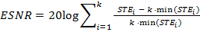 Eq. ---[2.2].
    - Time Frequency Masking
In this step the mask is created and is applied on the frame. The actual function of the technique happens in this step only, i.e. to concentrate the speech information to lower frequencies.
Steps are:
- Convolving frame with 11*11 mean filter [11].
- Now normalize and dc shift the convolution result by subtracting it with minimum value and dividing it by the largest value
- Set the threshold value using eq.4, where a=0.047 and b=0.8.

Eq. ---[2.3]
- If the value in mask is less than threshold than value of that point is 1, otherwise it is 0.1

    - Mean Smoothing Filtering
Since the noise power of AWGN keeps on changing from frame to frame. So to remove this instant variation, mean smoothing filter is to adaptive time frequency masked map. Average of 3 frequency frame are calculated.

  - HILBERT HUANG TRANSFORMATION
Usually, FFT is use to convert signal from time domain to frequency domain. But, the drawback is, FFT assumes the data to be stationary and linear. But, speech signal are not stationary. So to construct more physically meaningful system HHT is implemented.
HHT is implemented in two steps, one is EMD process; which deconstructs the signal into intrinsic mode functions and other is amplitude-frequency extraction; which extracts the time-frequency information from each IMF, using Hilbert transform.
Steps are:
3.3.1) Empirical Mode Decomposition process
This step finds all the intrinsic mode functions (IMFs) in the signal . EMD process deconstructs the signal into set of IMF’s. Each IMF, extracted from signal by series of shifting, has two properties, first, number of zero crossing and extrema differ by at most 1 and second, mean value of envelopes defined by local maxima and local minima is zero. Unlike the harmonic functions of a Fourier series, these oscillatory functions may vary in both amplitude and frequency over time. In this decomposition process, the first IMF contains the highest frequencies associated with the original signal; each subsequent IMF contains lower-frequency components.
Steps for computing EMD are:
- Find the local peaks signal
- Form the cubic spline of these peaks
- Compute the average, say avg, of splines
- Perform
- Calculate the number of zero-crossings, z, and peaks, p, in to check the monotonicity of
- If repeat steps: ‘a’ to ‘e’, otherwise calculate residue
- Repeat steps ‘a’ to ‘f’ till r(t) have such as
Every summing vector in above equation is an IMF of

3.3.2) Amplitude and frequency extraction
It is a step to find frequency domain data of the signal . The Hilbert transform of the signal is computed to form an analytical signal. In this analytical signal, is the real part and Hilbert transform computed is the imaginary part. Since the signal is non stationary, the discrete cosine transform of the analytical signal is calculated. The resultant signal is the required amplitude spectrum of the input speech signal.
- Calculate the Hilbert transform of x(t), h(t)
- Form the analytical value, y(t), by combining the value calculated in above step as imaginary value and x(t) as real value. [6]
- Now calculate the DCT of y(t) [7]

  - MEL FREQUENCY CEPSTRAL COEFFICIENTS
The Mel-Frequency Cepstrum Coefficients (MFCC) is a representation defined as the real cepstrum of a windowed short-time signal derived from the FFT of that signal. The difference from the real cepstrum is that a nonlinear frequency scale is used, which approximates the behavior of the auditory system. In this thesis, 12 MFCC features are extracted from speech signal. MFCC uses the 20 overlapped warped triangular shaped filters, as shown in Fig. 3.2. In mel scale these filters are equally spaced. Since the relation between mel and frequency scale is non- linear, these filters are termed as warped filters [3]. Relation between mel and frequency scale are given by Eq.1 [3]
Eq. ---[2.4]
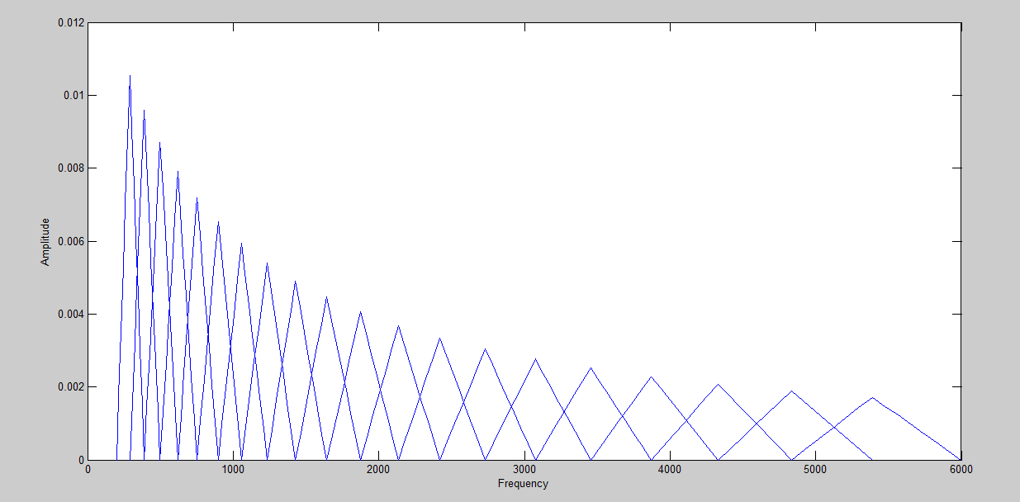
Fig 3.2 Triangular filters used in the computation of the mel-cepstrum using Eq. [6]
Steps for MFCC are as follows [1]:
- Set the range, say R, of filter bank, R have lowest and highest filter bank frequency values
- Set the number of desired coefficients from each filter, say k
- Get 20 equally spaced values in range R in mel scale
- From the above calculated values and k, form 20 overlapped triangular shaped filters in frequency scale, using Eq.2 [1]

k]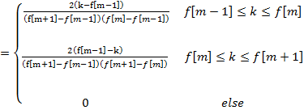 Eq. ---[2.5]

- Pass the signal through these filters and obtain filter output.
- For each filter perform sum of logarithm of each filter output, to obtain 20 different values
- Now perform DCT on these values to obtain the time domain signal, set n as 12
- Calculate the delta and delta delta of MFCC and their log energy features are calculated.

  - LINDE BUZO GRAY ALGORITHM
It is a vector quantization technique use to form the codebook for the given data. It is similar to K-mean algorithm.
Steps to form codebook are as follows [8,9]:
- Decide the K value, it the number of centroids needed to form codebook, and a variable err, it is a small number to show deviation in values from centroid
- Calculate the mean vector (centroid c) and mean square error, say D, of deviation of every data vector from the centroid.
- Now set variable m as 2 and centroid with range c-err to c +err. Using these values assign centroid to each data vector.
- From above data update codebook by calculating new centroid for each area
- Now calculate the mean square error for deviation of every data vector from their respective centroids, say D’
- Change the value of m to 2*m if value D’ < D, otherwise perform steps ‘c’ to ‘e’ again
- Repeat steps ‘b’ to ‘f’ till value of m is less than that of K.

- DESIGN APPROACH AND DETAILS

  - DESIGN APPROACH
As discussed in Section 1.1 that pre emphasizing and FFT can result in decrease of the efficiency and physically less realistic ASR model. So to mitigate these problems, the adaptive time frequency masking technique and Hilbert Huang Transform are used.
In speech signals, most of the useful data is located in lower frequency regions only [1,3]. So removing the highest frequencies from signal will not much affect the information of the speech. Also, the energy of this noise is almost constant. Fig 2 shows the spectrum of input signal obtained by general system. So to remove noise different approach is taken. For this new approach, firstly the pre-emphasizing step is avoided, as this step boosts the noise amplitude and then FFT is replaced by HHT, to make system more realistic. Fig. 4.1 shows the block diagram of proposed method.

INPUT SIGNAL

WINDOWING
SNR ESTIMATION

TIME FREQUENCY MASKING

MEAN SMOOTHING FILTERING

HHT

MFCC

VECTOR QUANTISATION
TRAINING
Training includes,
Till this part only
DECISION MAKING

RECOGNISED NUMBER

Fig.4.1 Block diagram of proposed isolated word recognition system
The proposed method is implemented and compared with the state of the art systems like adaptive time frequency masking and with FFT. The system is trained on the speech data recorded by the three speakers, each of them three times pronounces the 0-9 English numbers. The numbers are recorded at 16 kHz.
In isolated word recognition system each number signal is framed by 25ms overlapped hamming window with the overlapping of 25%. The ESNR is calculated for entire signal. This ESNR will be utilized later in the adaptive time frequency making. Then, HHT of each frame is calculated and adaptive time frequency masking is applied on each HHT frame. Then, the MFCC and dynamic features are calculated. Extracted features are clustered by LBG algorithm.
The testing of the system is also implemented on the speech data recorded by the same users that had contributed for training purpose. Also, one more unknown user’s speech data is recorded to find the stability of designed system to unknown user. Each speaker, three times pronounces the 0-9 English numbers. The numbers are recorded at 16 kHz. All the training and testing is done in MATLAB [10].
For the general system, FFT and pre emphasizing are utilized with no HHT and no masking. Also, in every system, two sub-system are made. One which utilizes vector quantization technique and one which do not utilize it. Table1 shows the desired block. Fig. 4.2 shows the observational approach taken.
General Method with LBG Algorithm
System with FFT + Masking, with LBG Algorithm
System with FFT + Masking, with LBG Algorithm

System with FFT + Masking, without LBG Algorithm

General Method without LBG Algorithm
System with FFT + Masking, without LBG Algorithm

Fig 4.2 Observational Approach
  - CODES AND STANDARDS
Programming Language: MATLAB
Standards: a. Speech signal is recorded at 16 kHz
b. Hamming window of size of 25ms with overlapping of 25% is used

  - CONSTRAINTS, ALTERNATIVES AND TRADEOFFS
Since the isolated word recognition requires the implementation and simulation of a real-life scenario, a number of assumptions have been made to address the constraints and trade-offs in the software simulation of such a case and hence make it possible and also for simplicity of calculations.
- Assumption used is that, only Additive White Gaussian Noise (AWGN) is present in this system.
- The other types of noises are neglected noise.
- Only English numbers 0-9 are considered in this system
- Speech signal is recorded at 16 kHz and the windowing and all further processes include the same sampling frequency
- Recording duration of every isolated word is 3sec
- The window size of 25ms with overlapping of 25% is considered
- Window used is hamming window
- Inbuilt function for creating window is used
- Frames with total sum of 0.015 or less are neglected
- Estimated SNR is used for getting the threshold value for masking
- Values of cell in mask is 0.1 if value is less than the threshold and 1 if value is equal or more than the threshold.
- Value of the masked output is normalized to get uniform range
- Mean smoothing filtering of order 3 is used
- DCT is used for getting the frequency domain data
- Inbuilt functions of DCT and Hilbert transform are used
- Filter2() is used for obtaining the output from the filter
- First 12 MFCC features are taken and their delta and delta delta features are calculated.
- Dynamic features are calculated using diff()
- Value of k is taken as 16 in LBG Algorithm
- Decision making step uses the minimum SSE approach to compare the training and testing data set.
- Results are shown on the basis of percentage of improvement with respect to general system
- In total six system are used for observation
- Noise level is estimated by ESNR of input signal and that of masked signal
- SCHEDULE, TASKS & MILESTONES

The project was completed in a systematic manner where the final algorithm was developed through a series of steps taken in proposed method. The simulations were carried out completely in MATLAB software. The following schedule was followed:

Table 5.1: Rough schedule followed and tasks completed.
S. NO. | MONTH | TASKS
1 | JANUARY | Initial research in speech signal processing techniques
2 | FEBRUARY | Designing of adaptive time frequency masking technique
3 | MARCH | Designing of Hilbert Huang Transform technique
4 | APRIL | Designing of LBG Algorithm, other sub-system and decision making step.

The milestones achieved during the course of this project are as under:
- Automation of the all the functions and techniques
- Reduction in the ESNR of the speech signal by using adaptive time frequency masking technique
- Successful implementation of HHT technique
- Successful creation of warped triangular shaped filters in range of 200 to 6 kHz
- Improvement in the efficiency of isolated word recognition

- PROJECT DEMONSTRATION
Project is experimentally performed in same way as mentioned in section 4.1. All the assumptions and constraints are also same as mentioned in section 4.3.
  - SYSTEM WORKFLOW
Step by step outputs are shown in following section:
- Input signal
Signal of 16 kHz and of 3sec duration is recorded.

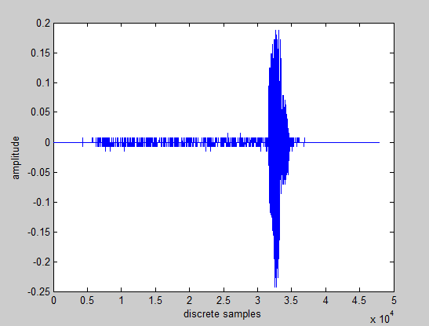
Fig 6.1: Input signal, English number 1

- Windowed signal
The hamming window of 25ms with overlapping of 25% is used

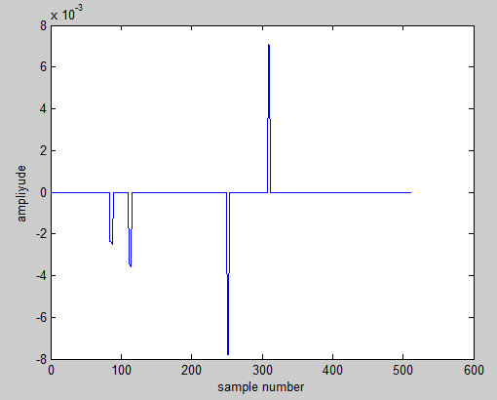
Fig 6.2: Frame 72 of input signal, English number 1

- Estimated SNR
ESNR of input signal is:
- Time frequency masking
The frame is masked with the adaptive mask prepared.

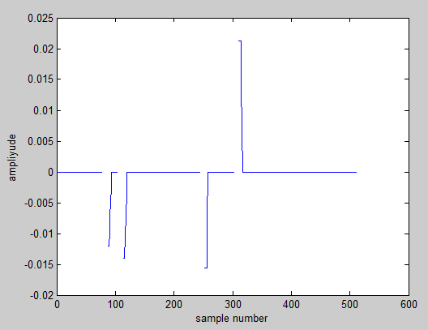
Fig 6.3: Time frequency masked output of frame 72 of input signal, English number 1

- Mean smoothing filtering
The output of time frequency masked smoothened using mean smooth filter of order 3

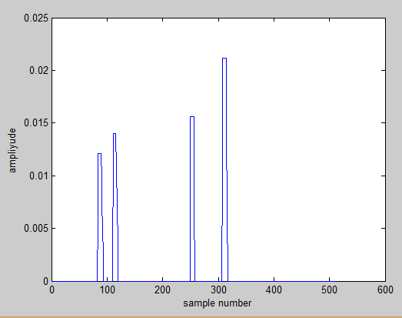
Fig 6.4: Mean smoothed masked output of frame 72 of input signal, English number 1

- HHT
Masked frame is passed for HHT. Here, HHT of 16k is calculated. In this step, signal is decomposed into IMFs and then using those IMFs, the analytical signal is computed. This analytical signal passed through DCT to obtain the frequency domain data of that frame.
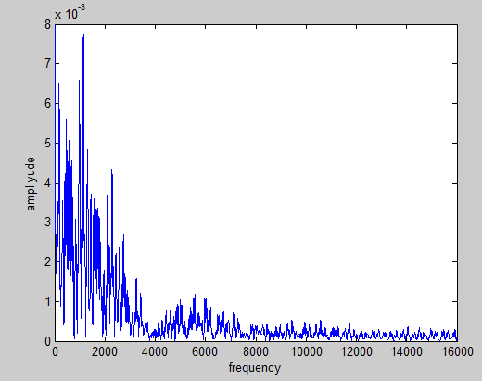
Fig 6.5: Frequency domain representation of frame 72 of input signal, English number

- MFCC
The frequency domain data is passed through the warped triangular filters shown in fig 3.2. The output of every filter is summed and from those, first 12 coefficients are only considered. To compute the dynamic features, the delta and delta delta of those 12 coefficients is calculated. Also, their respective energies are also calculated. Thus, total 39 features are calculated from every frame.
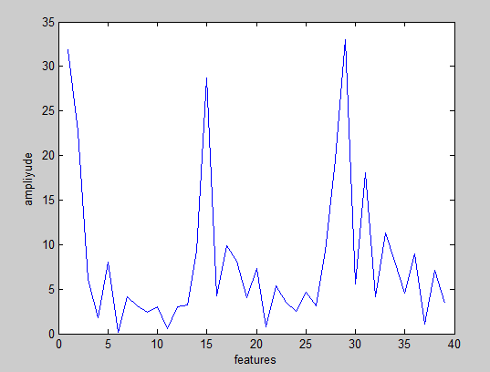
Fig 6.6: MFCC of frame 72 of input signal, English number 1

- Vector Quantization
From here onwards all the calculations are computed without graphical reference. From, here the system is divided into two sub-systems, one with LBG Algorithm and other without it.
After extracting the MFCC features, for one sub-system LBG Algorithm is implemented on the extracted features, to map the data to form codebook.

- Training
During training of the system, the data collected is stored in the database with the English number it belongs to. This data is stored in the form of cell in the MATLAB. And, during testing phase the data is taken from the database to compute the decision making part.

- Decision making
This part is only computed during testing of the system. The decision making is based on statistical results given by Sum of Squared Error (SSE) method [13]. The training set’s digit with minimum SSE is the recognised ouput.

- Recognized Output
The number in training data set whose corresponding data set yields the minimum SSE with respect to testing signal is displayed as the recognized number.

  - RESULTS
In this section the experimental results are presented. The results are presented in three sub-section; improvement in estimated signal to noise ratio, unknown speaker’s word recognition rate and improvement in known speaker’s word recognition rate. The decision making is based on statistical results given by Sum of Squared Error (SSE) method [13]. The training set’s digit with minimum SSE is the recognised ouput.
    - Improvement in estimated signal to noise ratio
Improvement in the estimated signal to noise ratio is presented in Table 6.1. The table shows the ESNR of the input signal and that of maked signal. Table 6.1 shows that proposed method reduces noise in the input signal by atleast 25%. Fig. 6.7 shows the spectrum of input signal otained by general and proposed system graphically. From Fig. 6.7, it can be said that ESNR is increased in proposed system.
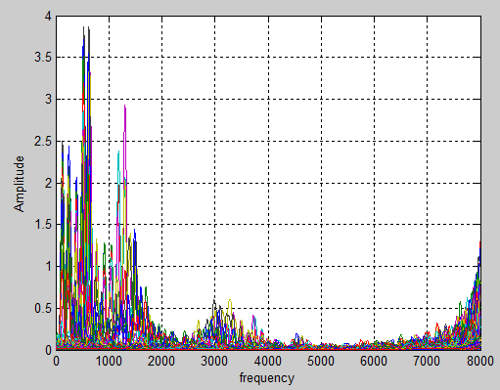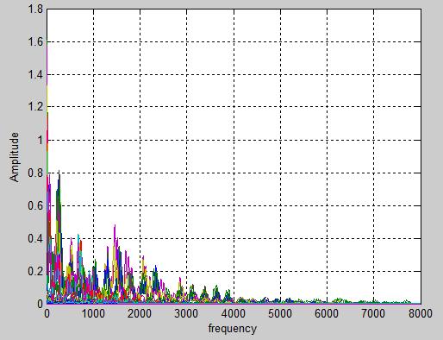
Fig 6.7: Spectrum of input signal, obtained by general system (left) and Spectrum of input signal, obtained by proposed system (right)

TABLE 6.1: Improvement in ESNR
Digit spoken  (0-9) | ESNR |  | Percentage  Improvement by masking
Digit spoken  (0-9) | Before masking | After masking | Percentage  Improvement by masking
0 | 76.09 | 110.26 | 44.91
1 | 53.61 | 84.13 | 56.92
2 | 84.53 | 121.9 | 44.21
3 | 51.67 | 83.57 | 61.73
4 | 85.9 | 109.8 | 27.8
5 | 82.45 | 105.72 | 28.22
6 | 79.01 | 102.12 | 29.25
7 | 84.71 | 115.87 | 36.78
8 | 78.08 | 100.56 | 28.8
9 | 74.25 | 107.62 | 44.94

    - Unknown speaker’s word recognition rate
The word recognition rate of unknown speaker’s data set is zero. This means that given system cannot be used by the unknown speakers.
    - Improvement in known speaker’s word recognition rate
Table 6.2 shows improvement in considered systems with respect to general system. The word recognition rate varies from sub-system to sub-system. The improvement by proposed system for the sub-system with LBG algorithm is 3% and for the sub-system without LBG algorithm is 23.33%.
TABLE 6.2: Improvement by systems with HHT+masking and FFT+masking
Sub-System | FFT + MASKING | HHT + MASKING
WITHOUT LBG | 13.33% | 23.33%
WITH LBG | 3% | 3%

- COST ANALYSIS
In comparison to general method of ASR system, the time cost of the proposed system is more.
- The time required for computing the mask values of every frame and then applying it on that frame, is more as compare to pre emphasizing step.
- The calculating of HHT coats more time than calculating FFT for same number of frequency values. This is due to the shifting step in EMD that costs more time. Sometimes, if the signal is highly non stationary, the time increases for computation of HHT. This due to difficulty in finding the IMFs in such a highly complex non stationary data.
- Since the proposed method is only simulated on MATLAB, which works on PCS, this also restricts the time cost of the processor and the RAM of the system.

- SUMMARY
In this paper a proposed method has been developed to increase the word recognition rate of the isolated word recognition. The performance of the proposed system was examined on the data set recorded by four speakers. The proposed system is divided into two sub-systems, one with LBG algorithm and other without it.
In isolated word recognition system each number signal is framed by 25ms overlapped hamming window with the overlapping of 25%. The ESNR is calculated for entire signal. This ESNR will be utilized later in the adaptive time frequency making. Then, HHT of each frame is calculated and adaptive time frequency masking is applied on each HHT frame. Then, the MFCC and dynamic features are calculated. Extracted features are clustered by LBG algorithm. The testing of the system is also implemented on the speech data recorded by the same users that had contributed for training purpose. Also, one more unknown user’s speech data is recorded to find the stability of designed system to unknown user. Each speaker, three times pronounces the 0-9 English numbers.
The experimental results shows that the proposed method cannot be used by unknown speakers. Also, it shows the improvement in the ESNR by at least 25% and thus the improvement in isolated word recognition by 3% and 23.33% in sub-systems in which one utilizes vector quantization technique and other do not respectively.
Our future work is to improve the decision making step by utilizing the knowledge and concepts of artificial neural networks, to increase the word recognition rate.

References
[1] L. R. Rabiner and Biing-Hwang Juang, “Fundamentals of speech recognition”, Printice HallSignal Processing Series, Alan V. Oppenheim, Series, Editor, 1993
[2] S. Pannirselvam and G. Balakrishnan, “Comparative study on preprocessing techniques on automatic speech recognition for Tamil language”, IJCA, 0975-8887, NCRIIAMI, 2015
[3] A. M. Gouda, M. Tamazin and M. Khedr, “Robust Automatic speech recognition system based on using adaptive time frequency masking”, IEEE, pp.181-186, 2016
[4] Fenglei Ma, X. Zhou and Y. Zheng, “Voice signal noise reduction based on Hilbert-huang transform”, Applied Mechanics and Materials, ISSN: 1662-7482, Vols. 303-306, pp. 1039-1042, 2013 [5] W. Song and J. Cai, “End to end deep neural network for automatic speech recognition system”, Stanford NLP group, 2015
[6] Huang, N. E., and Z. Wu, “A review on hilbert-huang transform: Method and its applications to geophysical studies”, Rev. Geophysics., 46, RG2006, 2008
[7] Vani H.Y., “Hilbert-huang transform based speech recognition”, Second International Conference on CCIP, 2016
[8] MIT, “Vector quantization and clustering”, Lecture-6, Session 2003, 6.345 Automatic Speech Recognition
[9] Roma Bharti and Priyanka Bansal, “Real time speaker recognition system using MFCC and vector quantization technique ”, IJCA, 0975-8887, Vol. 117 – No. 1, May 2015
[10] M. Saleem, Z. U. Rehman, U. Zahoor, A. Mazhar and M. R. Anjum, “Self learning speech recognition model using vector quantization”, IEEE, pp.199-2013,2016
[11] R. C. Gonzalez, R. E. Woods and S. L. Eddins,“Digital image processing using MATLAB”, 2 nd edition, 2002
[12] Stephen J. Chapman, “MATLAB Programming with Applications for Engineers”, 1st edition, 2013
[13] A. Lipeika, J. Lipeikiene and L Telksnys, “Development ofisolated word recognition system”, INFORMATICA, Vol. 13, No. 1, 37–46, 20
Publication Details

Topic | Isolated Words Recognition in Speech Signal Processing
Paper ID | IAETSDIJMR/131
Journal Name | IAETSD International Journal of Multee-Disciplinary Research, Volume 3, Issue 2, Mar-April/2017 ISSN (Online): 2454-1524
Authors | Rahul Khanna, Prof. S. Kalaivani
Pages | 264-270

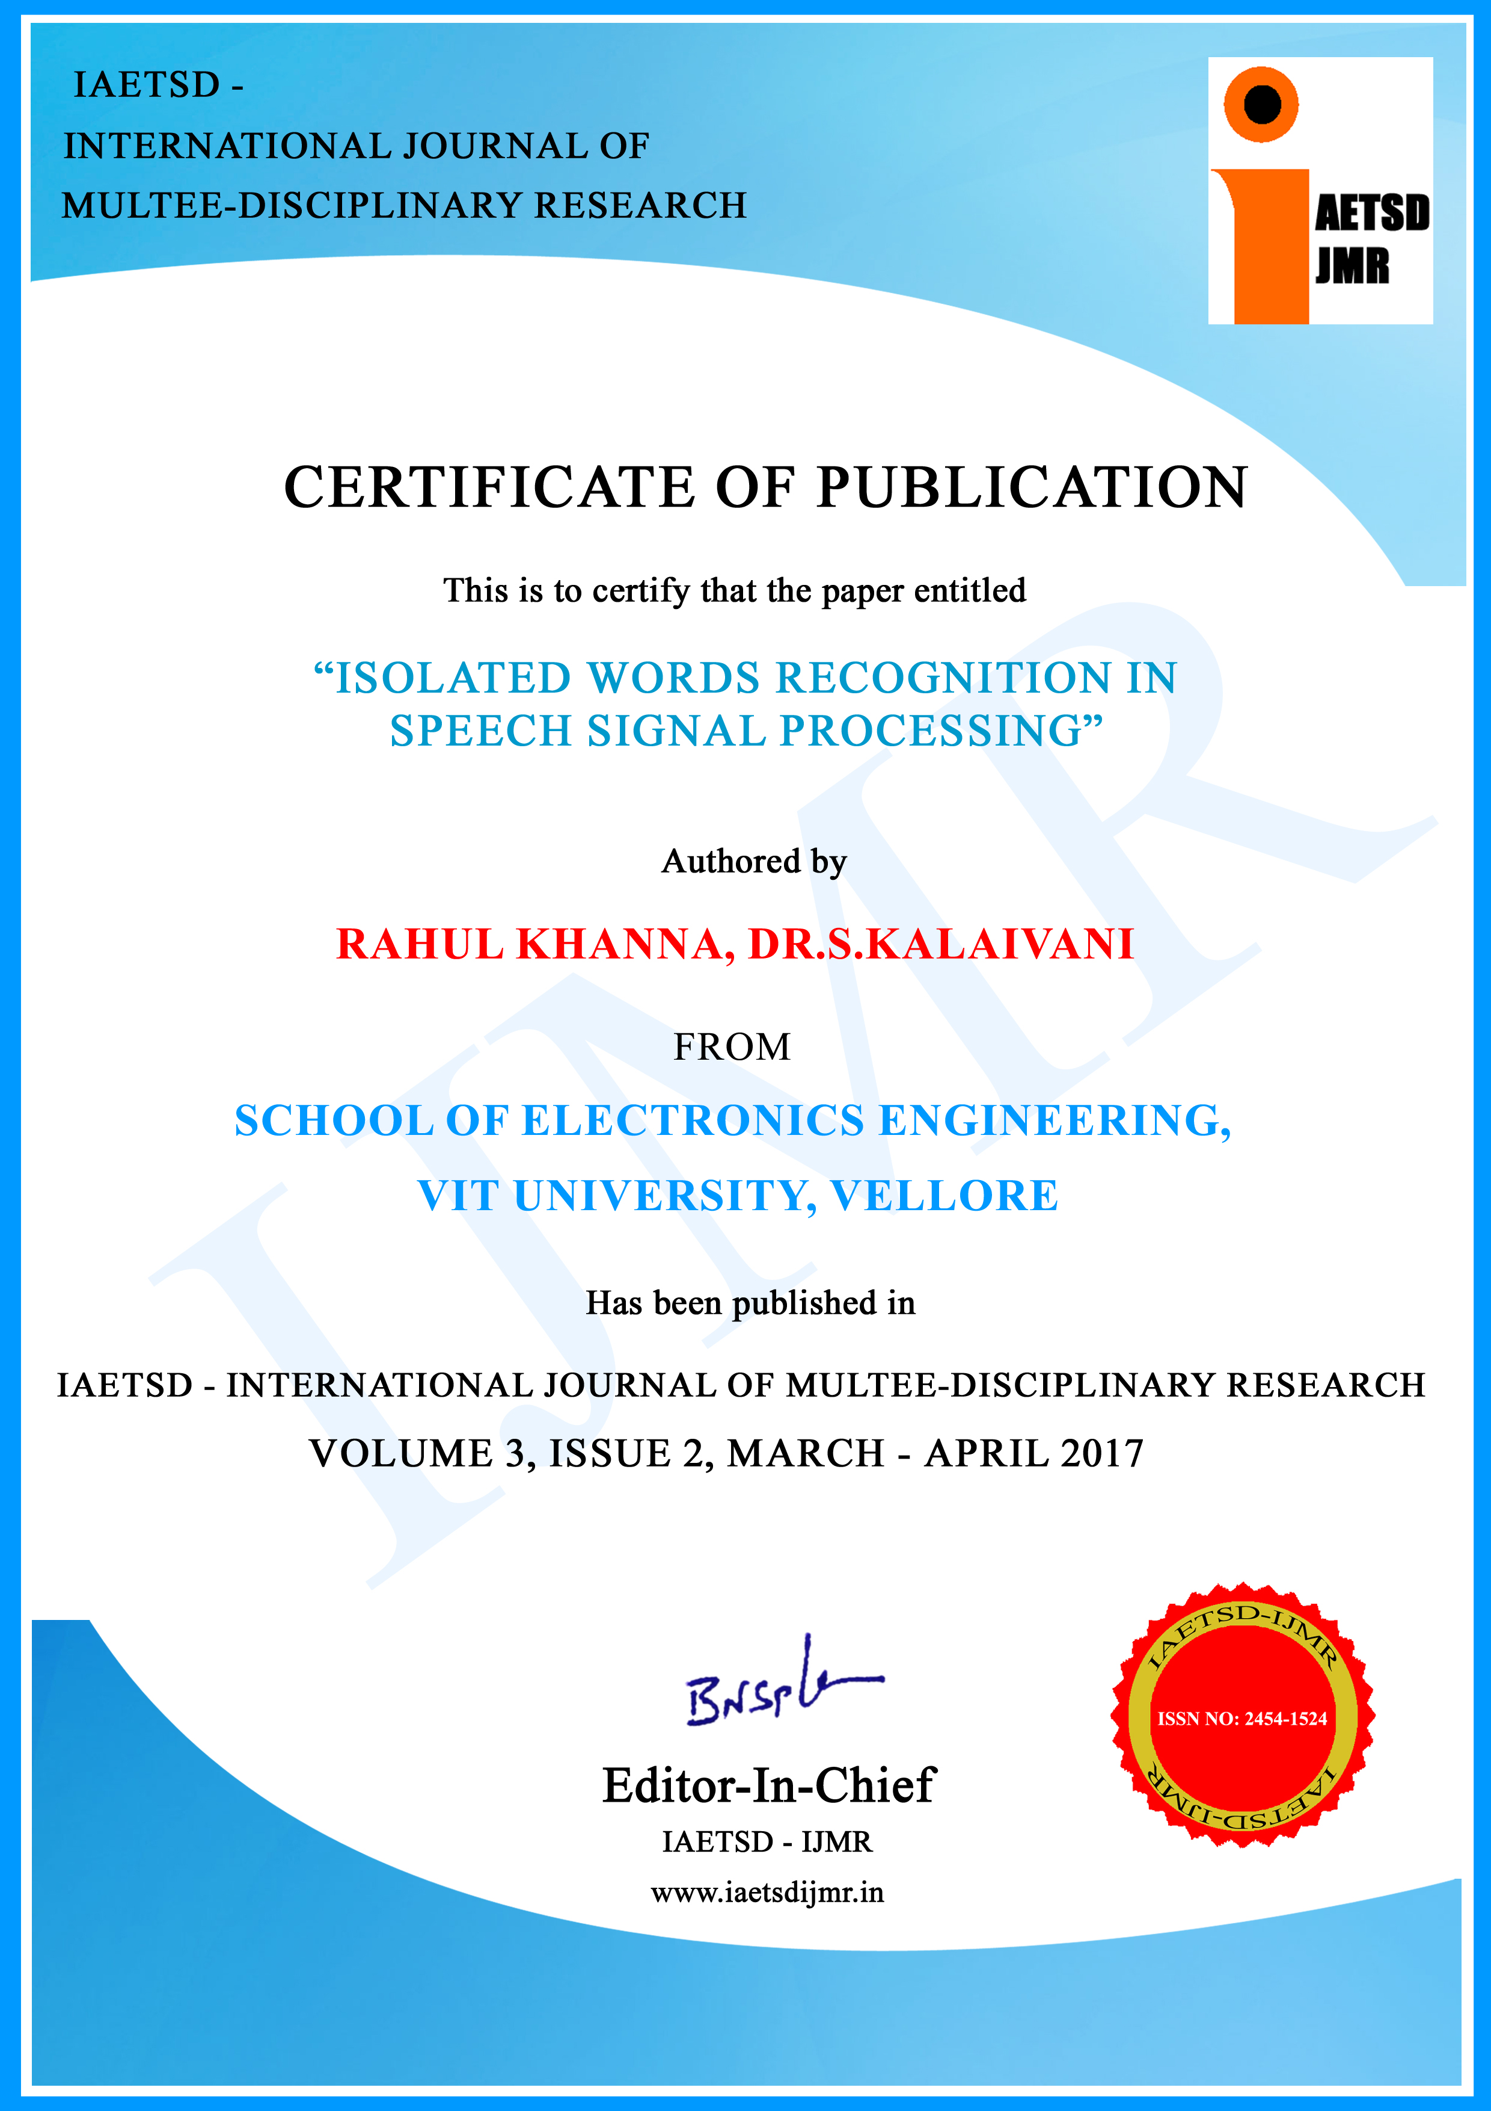

Curriculum vitae

Name : Rahul Khanna

Father’s name : Shree Ashok Khanna
Date of Birth : October 29th, 1994
Nationality : Indian
Sex : Male
Company placed : Temenos India Pvt. Ltd.
Permanent Address : 1-A, Street no-5
New Krishna Nagar,
Delhi-110051
Phone Number : 01122005376
Mobile : 9953658441, 9787114725
Email Id : rahulkhanna2910@gmail.com,
CGPA : 8.46
Placement Details : Placed at Temenos India Pvt. Ltd.as Software
Developer

